Command: PLINE

Specify start point: 0,-15

Current line-width is 0.0000

Specify next point or [Arc/Halfwidth/Length/Undo/Width]: 0,15

Specify next point or [Arc/Close/Halfwidth/Length/Undo/Width]: 80,15

Specify next point or [Arc/Close/Halfwidth/Length/Undo/Width]: A

Specify endpoint of arc (hold Ctrl to switch direction) or

[Angle/CEnter/CLose/Direction/Halfwidth/Line/Radius/Second pt/Undo/Width]: CE

Specify center point of arc: 80,0

Specify endpoint of arc (hold Ctrl to switch direction) or [Angle/Length]: A

Specify included angle (hold Ctrl to switch direction): -180

Specify endpoint of arc (hold Ctrl to switch direction) or

[Angle/CEnter/CLose/Direction/Halfwidth/Line/Radius/Second pt/Undo/Width]: CL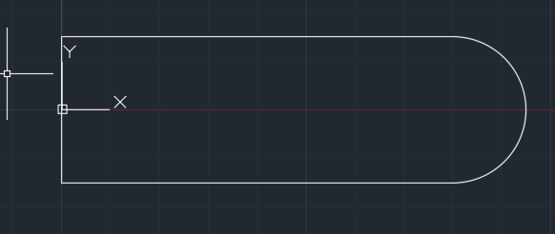

Command: MIRROR

Select objects: 1 found

Select objects:

Specify first point of mirror line: 0,15

Specify second point of mirror line: 0,-15

Erase source objects? [Yes/No] <No>: N

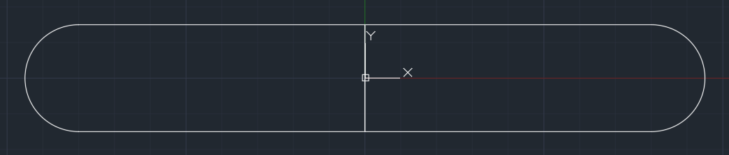

Command: CIRCLE

Specify center point for circle or [3P/2P/Ttr (tan tan radius)]: 80,0

Specify radius of circle or [Diameter]: D

Specify diameter of circle: 15

Command: CIRCLE

Specify center point for circle or [3P/2P/Ttr (tan tan radius)]: -80,0

Specify radius of circle or [Diameter] <7.5000>: D

Specify diameter of circle <15.0000>: 15

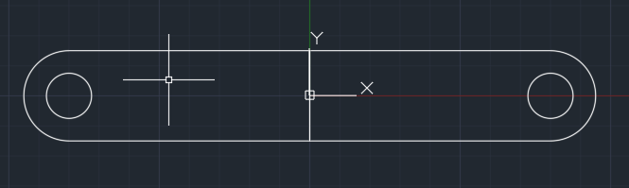

Command: REGION

Select objects: 1 found

Select objects: 1 found, 2 total

Select objects:

2 loops extracted.

2 Regions created.

Command: REGION

Select objects: 1 found

Select objects: 1 found, 2 total

Select objects:

2 loops extracted.

2 Regions created.

Command: EXTRUDE

Current wire frame density: ISOLINES=4, Closed profiles creation mode = Solid

Select objects to extrude or [MOde]: 1 found

Select objects to extrude or [MOde]: 1 found, 2 total

Select objects to extrude or [MOde]:

Specify height of extrusion or [Direction/Path/Taper angle/Expression]: 10

Command: EXTRUDE

Current wire frame density: ISOLINES=4, Closed profiles creation mode = Solid

Select objects to extrude or [MOde]: 1 found

Select objects to extrude or [MOde]: 1 found, 2 total

Select objects to extrude or [MOde]:

Specify height of extrusion or [Direction/Path/Taper angle/Expression] <10.0000>: 30

Command: SUBTRACT

Select solids, surfaces, and regions to subtract from ..

Select objects: 1 found

Select objects:

Select solids, surfaces, and regions to subtract ..

Select objects: 1 found

Select objects:

Command: SUBTRACT

Select solids, surfaces, and regions to subtract from ..

Select objects: 1 found

Select objects:

Select solids, surfaces, and regions to subtract ..

Select objects: 1 found

Select objects: 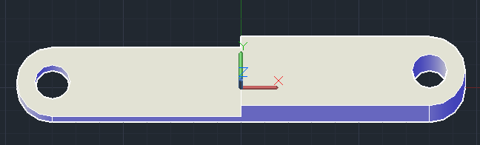

Command: PLINE

Specify start point: 65,-15,10

Current line-width is 0.0000

Specify next point or [Arc/Halfwidth/Length/Undo/Width]: 95,-15

Specify next point or [Arc/Close/Halfwidth/Length/Undo/Width]: 95,15

Specify next point or [Arc/Close/Halfwidth/Length/Undo/Width]: 65,15

Specify next point or [Arc/Close/Halfwidth/Length/Undo/Width]: C

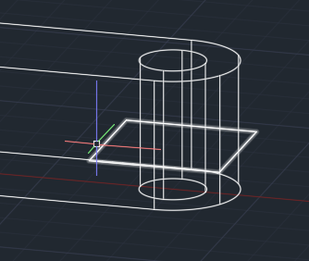

EXTRUDE

Current wire frame density: ISOLINES=4, Closed profiles creation mode = Solid

Select objects to extrude or [MOde]: 1 found

Select objects to extrude or [MOde]:

Specify height of extrusion or [Direction/Path/Taper angle/Expression] <30.0000>: 10

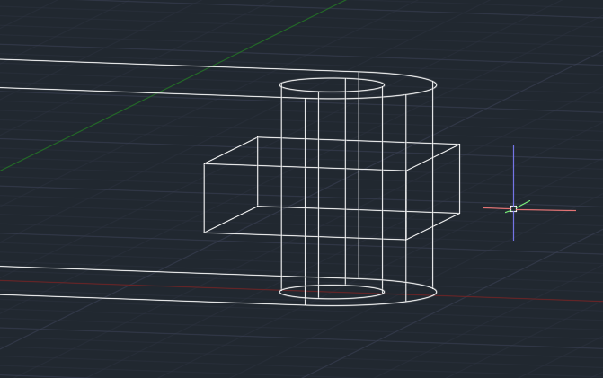

Command: SUBTRACT

Select solids, surfaces, and regions to subtract from ..

Select objects: 1 found

Select objects:

Select solids, surfaces, and regions to subtract ..

Select objects: 1 found

Select objects:

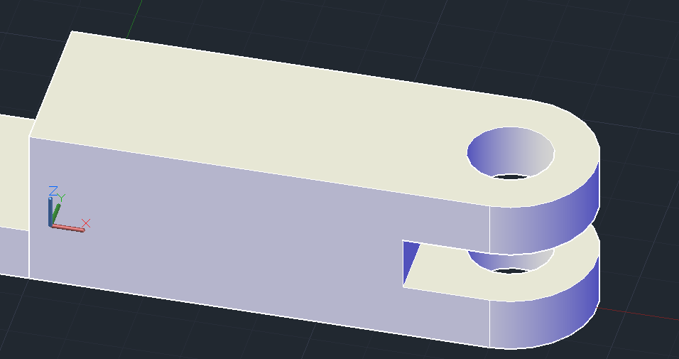

Command: PLINE

Specify start point: 55,-15,10

Current line-width is 0.0000

Specify next point or [Arc/Halfwidth/Length/Undo/Width]: 0,-15,10

2D point or option keyword required.

Specify next point or [Arc/Halfwidth/Length/Undo/Width]: 55,15

Specify next point or [Arc/Close/Halfwidth/Length/Undo/Width]: 0,15

Specify next point or [Arc/Close/Halfwidth/Length/Undo/Width]: 0,-15

Specify next point or [Arc/Close/Halfwidth/Length/Undo/Width]: C

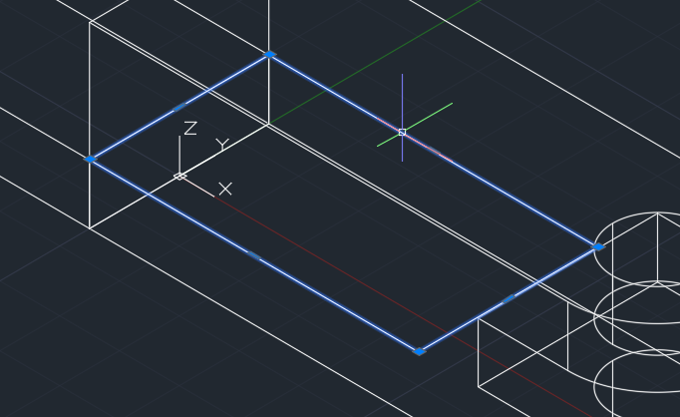

EXTRUDE

Current wire frame density: ISOLINES=4, Closed profiles creation mode = Solid

1 found

Specify height of extrusion or [Direction/Path/Taper angle/Expression] <10.0000>: 80

Command: Regenerating model.

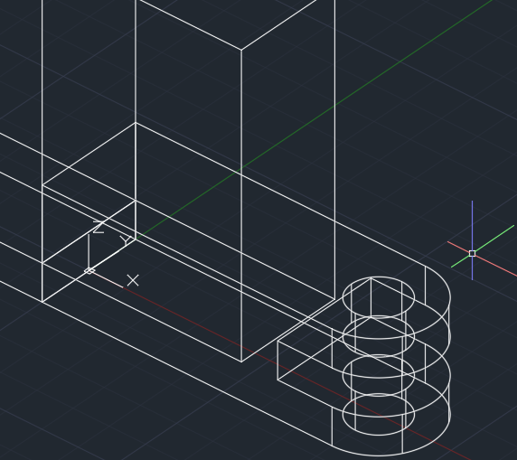

Command: SUBTRACT

Select solids, surfaces, and regions to subtract from ..

Select objects: 1 found

Select objects:

Select solids, surfaces, and regions to subtract ..

Select objects: 1 found

Select objects:

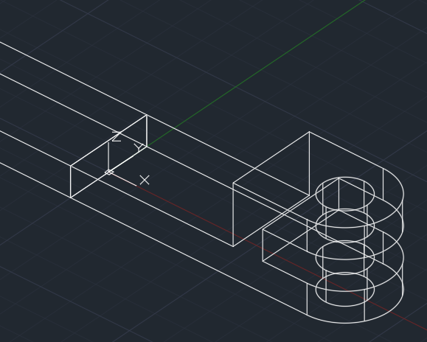

Command: 3DPOLY

Specify start point of polyline: 0,-6,10

Specify endpoint of line or [Undo]: 55,-6,10

Specify endpoint of line or [Undo]: 55,-6,30

Specify endpoint of line or [Close/Undo]: 5,-6,110

Specify endpoint of line or [Close/Undo]: 0,-6,110

Specify endpoint of line or [Close/Undo]: C

Command: EXT

EXTRUDE

Current wire frame density: ISOLINES=4, Closed profiles creation mode = Solid

Select objects to extrude or [MOde]: 1 found

Select objects to extrude or [MOde]:

Specify height of extrusion or [Direction/Path/Taper angle/Expression]: 12

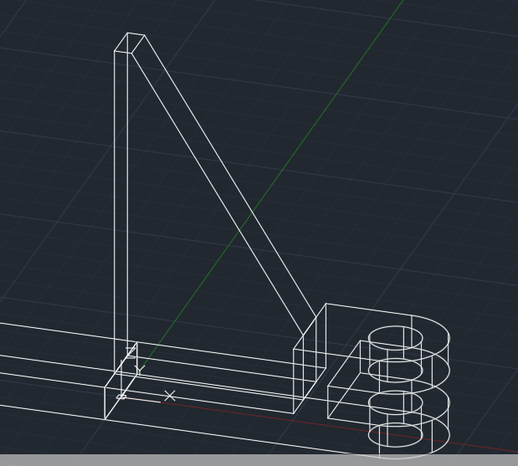

Command: 3DPOLY

Specify start point of polyline: 0,-6,10

Specify endpoint of line or [Undo]: -70,-6,10

Specify endpoint of line or [Undo]: -10,-6,100

Specify endpoint of line or [Close/Undo]: 0,-6,100

Specify endpoint of line or [Close/Undo]: C

Command: EXTRUDE

Current wire frame density: ISOLINES=4, Closed profiles creation mode = Solid

Select objects to extrude or [MOde]: 1 found

Select objects to extrude or [MOde]:

Specify height of extrusion or [Direction/Path/Taper angle/Expression] <12.0000>: 12

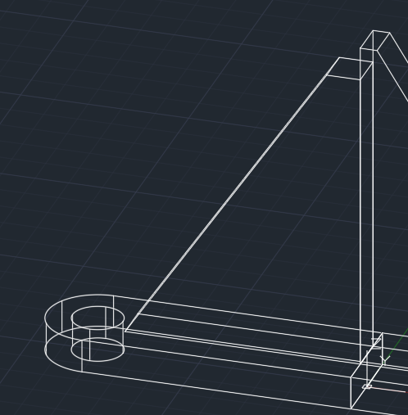

Command: ROTATE3D

Current positive angle: ANGDIR=counterclockwise ANGBASE=0

Select objects: 1 found

Select objects: 1 found, 2 total

Select objects:

Specify first point on axis or define axis by

[Object/Last/View/Xaxis/Yaxis/Zaxis/2points]: Z

Specify a point on the Z axis <0,0,0>:

Specify rotation angle or [Reference]: 15

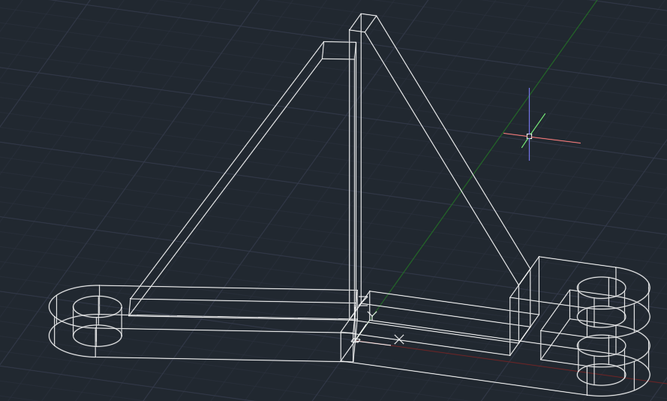

Command: CIRCLE

Specify center point for circle or [3P/2P/Ttr (tan tan radius)]: 0,0,0

Specify radius of circle or [Diameter]: D

Specify diameter of circle: 60

EXTRUDE

Current wire frame density: ISOLINES=4, Closed profiles creation mode = Solid

Select objects to extrude or [MOde]: 1 found

Select objects to extrude or [MOde]:

Specify height of extrusion or [Direction/Path/Taper angle/Expression] <12.0000>: 90

CIRCLE

Specify center point for circle or [3P/2P/Ttr (tan tan radius)]: 0,0,0

Specify radius of circle or [Diameter] <30.0000>: D

Specify diameter of circle <60.0000>: 40

Command: EXTRUDE

Current wire frame density: ISOLINES=4, Closed profiles creation mode = Solid

Select objects to extrude or [MOde]: 1 found

Select objects to extrude or [MOde]:

Specify height of extrusion or [Direction/Path/Taper angle/Expression] <90.0000>: 150

Command: Regenerating model.

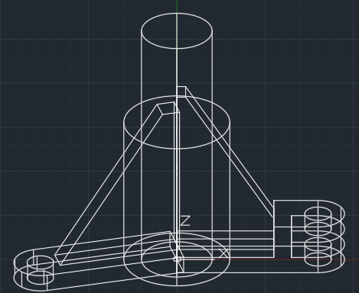

UNION

Select objects: 1 found

Select objects: 1 found, 2 total

Select objects: 1 found, 3 total

Select objects: 1 found, 4 total

Select objects: 1 found, 5 total

Select objects:

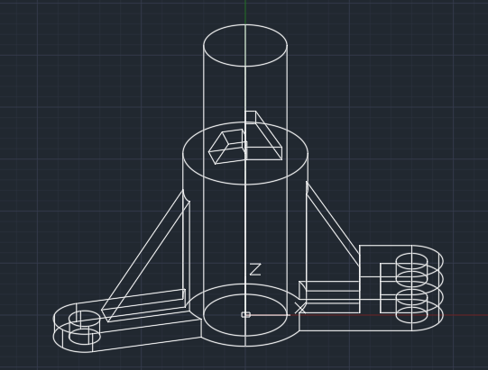

Command: SUBTRACT

Select solids, surfaces, and regions to subtract from ..

Select objects: 1 found

Select objects:

Select solids, surfaces, and regions to subtract ..

Select objects: 1 found

Select objects:

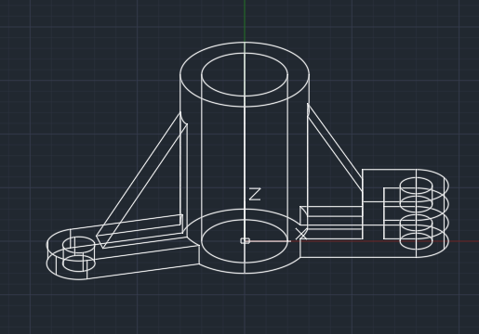

Command: ROTATE3D

Current positive angle: ANGDIR=counterclockwise ANGBASE=0

Select objects: 1 found

Select objects:

Specify first point on axis or define axis by

[Object/Last/View/Xaxis/Yaxis/Zaxis/2points]: X

Specify a point on the X axis <0,0,0>:

Specify rotation angle or [Reference]: -90

Command: ROTATE3D

Current positive angle: ANGDIR=counterclockwise ANGBASE=0

Select objects: 1 found

Select objects:

Specify first point on axis or define axis by

[Object/Last/View/Xaxis/Yaxis/Zaxis/2points]: Y

Specify a point on the Y axis <0,0,0>:

Specify rotation angle or [Reference]: -90

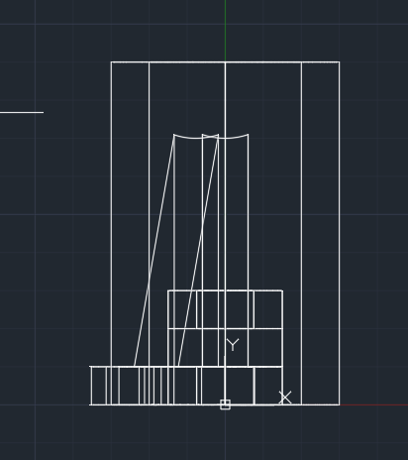

Command: CIRCLE

Specify center point for circle or [3P/2P/Ttr (tan tan radius)]: 0,75

Specify radius of circle or [Diameter]: D

Specify diameter of circle: 10

Current wire frame density: ISOLINES=4, Closed profiles creation mode = Solid

Select objects to extrude or [MOde]: 1 found

Select objects to extrude or [MOde]:

Specify height of extrusion or [Direction/Path/Taper angle/Expression]: Regenerating model.

Resuming EXTRUDE command.

Specify height of extrusion or [Direction/Path/Taper angle/Expression]: Regenerating model.

Resuming EXTRUDE command.

Specify height of extrusion or [Direction/Path/Taper angle/Expression]: 100

Command: SUBTRACT

Select solids, surfaces, and regions to subtract from ..

Select objects: 1 found

Select objects:

Select solids, surfaces, and regions to subtract ..

Select objects: 1 found

Select objects:

